ME780 Assignment 1

by

Philopatear Salib

ME780 Vehicle System Dynamics
University of Waterloo
Fall 2020

Introduction
Many research papers have addressed vehicle yaw stability control using differential braking as an essential approach for many applications. It has shown remarkable results in lane-keeping assistance control [1] [2], collision avoidance [3], and redundancy for both electric power assisted steering in non-autonomous vehicles [4] and for steering systems in autonomous vehicles [5]. While vehicles having differential braking control have exhibited a great capability of achieving the desired yaw rate, it did not usually match the longitudinal response expected by the driver [6]. This has brought the attention to integrate it with active torque distribution [6] or with active aerodynamic control [7] with the aim of providing active control of both traction and yaw moment.
Diverse control algorithms are employed as an approach for the applications. The control strategy is usually based on an upper control and a lower controller. The upper controller calculates the desired yaw rate from a linear 2 DOF vehicle model, compares it to the actual yaw rate measured, and obtains the corrective yaw moment required to achieve the vehicle stability. While the lower controller act as a brake torque distributor according to the yaw rate angle and the amount of corrective yaw moment to be applied.
It is noticeable that most of the research papers which addressed the control algorithms of vehicle handling stability has utilized a linear bicycle model to calculate the desired yaw rate [1]- [3].The linear model is verified that it is sufficient enough to convey accurate yaw rate and side-slip angle for control algorithms and research studies [8].
Simple control strategies as feedforward control are adopted to adjust lateral shift of the vehicle with the aim of lane-keeping assist. The study results prove the proportionality between yaw rate and yaw moment which enables the system to achieve the nominal lateral shift with a 9% error [2].
Robust controllers are exploited for vehicle yaw stability control as based on Quantitative Feedback Theory (QFT). QFT controller can encounter changes in the vehicle parameters uncertainties while maintaining the vehicle yaw stability through differential braking. It obtains the corrective yaw moment from the calculated desired yaw rate and the provided steering angle. The simulation results do not only show enhancement in the vehicle yaw stability, but show accurate tracking of the desired yaw rate as well as the controller capability to overcome the vehicle’s uncertainties [9].
PID controllers are utilized diversely in controlling the vehicle yaw rate. One control architecture is based on a fuzzy controller and a convention PID. The fuzzy controller tunes the PID parameters according to the difference between the desired yaw rate and the measured yaw rate. Consequently, the PID controller feeds the brake distributor with the corrective yaw moment. The results show a noticeable improvement in the vehicle yaw stability and an acceptable tracking of the desired parameter [10].
Another control architecture that utilizes PID controllers is based on a conventional PID as the upper controller, and a fuzzy logic ABS controller as the lower controller and the brake distributer. Noting that the upper controller outputs the desired slip angle unlike the upper controllers discussed earlier which outputs the corrective yaw moment for vehicle yaw stability. The ABS controller is fed the measured wheels acceleration, and the difference between the desired wheel slip and the estimated actual side-slip angle of the vehicle. It outputs PWM control signals to each wheel indicating the amount of pressure required to maintain the desired yaw rate. The proposed control strategy proved its capability in tracking the ideal yaw rate [11].
The study in [12] employs 2 PID controllers and combine them together to provide the corrective yaw moment required for vehicle stability. One of the controllers is fed the deviation in yaw rate and the other is fed the deviation in the side-slip angle. The lower controller determines which wheel to brake based on the steering angle and the yaw rate deviation. On a snakelike lane-change maneuver, a simulation test is carried out. The test results show a remarkable reduction in the yaw rate and the side-slip angle fluctuations. Further explanation is discussed in the coming section.
It is clear that the high diversity in the control studies of the vehicle yaw stability using differential braking allows all vehicles manufacturers to implement an active safety system with a reasonable cost and high reliability for various safety applications.

Modeling and Methodology
The rest of this article is written on the basis of the study in [12].
A vehicle yaw stability controller is developed through integrating a PID controller with a differential braking system. The vehicle stability system includes an estimation of desired variables in the system, a differential braking system, and a controller design. The vehicle stability control is based on maintaining a nominal yaw velocity and a nominal side-slip angle. The control strategy proposed includes a PID controller for the yaw velocity and another one for the side-slip angle. Both linear controllers are combined together to provide the corrective yaw moment required for the vehicle yaw stability. The corrective yaw moment is calculated at the centroid of the vehicle. Therefore, it passes to a differential braking system which utilizes a braking force distribution strategy to maintain the vehicle stability.
The vehicle dynamics model considered includes an 8 degrees of freedom (DOF) vehicle model, a magic formula tire model, and an electric motor model for electric vehicles.
For the vehicle model, 4 DOF of the vehicle model includes the rotation motion of the 4 wheels, while the steering angle, the yaw angle, and the vertical and the horizontal displacement at the vehicle center of gravity are considered the rest DOF. The coordinate system of vehicle is shown below.
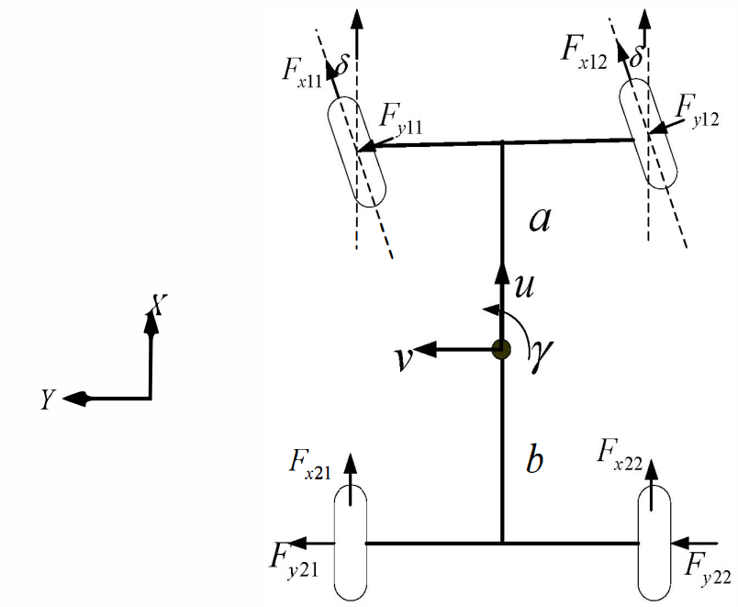
Figure 1 Coordinate system of the vehicle [12]
Assuming that the vehicle is a rigid body moving in XY plane, and not taking into consideration the pitch, roll or vertical motions of the vehicle. The longitudinal, lateral, and yaw motion equations can be obtained, respectively, from Newton’s second law as follows [12]:
$$m\left(\dot{u}-vγ\right)=\left(F_{x_{11}}+F_{x_{12}}\right)\cos{δ}-\left(F_{y11}+F_{y12}\right)sinδ+F_{x21}+F_{x22}-\frac{C_{D}A}{21.15}{\left(3.6\right)}^{2}$$
$$m\left(\dot{v}-uγ\right)=\left(F_{x_{11}}+F_{x_{12}}\right)\sin{δ}-\left(F_{y11}+F_{y12}\right)cosδ+F_{y21}+F_{y22}$$
$$I\dot{γ}=\frac{B}{2}\left[\left(F_{x_{12}}-F_{x_{11}}\right)\cos{δ}+\left(F_{y11}-F_{y12}\right)sinδ+F_{x22}+F_{x21}\right]+a\left[\left(F_{x_{12}}+F_{x_{11}}\right)\sin{δ}+\left(F_{y12}+F_{y11}\right)cosδ\right]-b(F_{y22}+F_{y21})$$
Where m is the sprung mass, $C_{D}$ is the drag coefficient, A is the vehicle frontal cross section area, I is the moment of inertia, B is the track width, a is the distance from the center of gravity to the front axle, b is the distance from the center of gravity to the rear axle.
The vehicle model provides the actual yaw rate and the actual side-slip angle for the controller.
The magic formula model is capable of conveying the nonlinear characteristics of the vehicle tires, thus considered as the most suitable tire model for the system. It provides the lateral forces, and the longitudinal forces for the 8 DOF vehicle model. For combined slip, the longitudinal force and the lateral forces for each wheel can be calculated as follows [12]:
$$F_{x}=\frac{δ_{x}}{δ}F_{x_{0}}$$
$$F_{y}=\frac{δ_{y}}{δ}F_{y_{0}}$$

Where
$$δ=\sqrt{δ_{x}^{2}+δ_{y}^{2}}, δ_{x}=\frac{\left|s_{x}\right|}{1+s_{x}}, δ_{y}=-\frac{\left|tanα\right|}{1+\left|s_{x}\right|}$$
$$F_{x0}=D\sin\left(C\arctan\left(Bϕ\right)\right)$$
$$F_{y0}=D\sin\left(C\arctan\left(Bϕ\right)\right)+ΔS_{v}$$
Where $s_{x}$ is the longitudinal slip, $α$ is the slip angle, $F_{x0}$ is the longitudinal slip, $F_{y0}$ is the lateral force, $S_{v}$ is the vertical shift, B, C, D and E are coefficients related to the magic formula tire model, and $ϕ=\left(1-E\right)s_{x}+\left(\frac{E}{B}\right)\arctan\left(Bs_{x}\right).$
The control architecture utilizes a linear 2 DOF vehicle model to calculate the desired yaw rate and desired side-slip angle. The desired variables can be calculated from the following equations:
$$\left(k_{1}+k_{2}\right)β+\frac{1}{u}\left(ak_{1}-bk_{2}\right)ω_{r}-k_{1}δ=m\left(\dot{v}+uω_{r}\right)$$
$$\left({ak}_{1}-bk_{2}\right)β+\frac{1}{u}\left(a^{2}k_{1}+b^{2}k_{2}\right)ω_{r}-{ak}_{1}δ=I_{z}\dot{ω_{r}}$$
Where $k_{1}$ is the front wheel cornering stiffness, $k_{2}$ is the rear wheel cornering stiffness, $β$ is the side-slip angle, $ω_{r}$ is the desired yaw velocity, $I_{z}$ is the rotational velocity.
The controlled variables are compared to their corresponding from the vehicle model. Each deviation calculated is passed to its corresponding PID controller. The control parameters are tuned by Ziegler–Nichols method enabling the controller to obtain the suitable yaw moment to track the desired yaw rate. The corrective yaw moment calculated is passed to the differential braking control, which applies certain braking forces to each wheel according to the braking force distribution strategy described below.
Table 1 Braking Force Distribution Strategy [12]
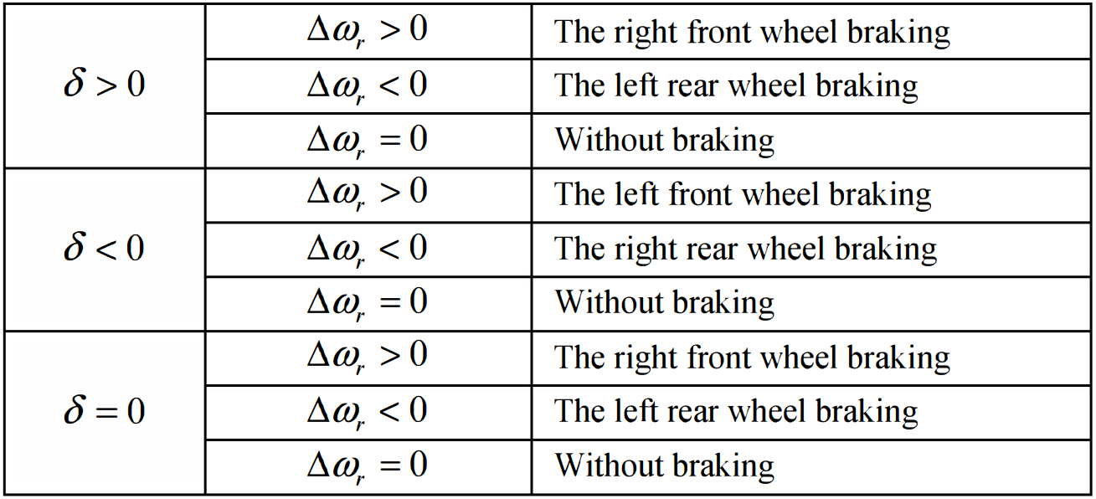

Simulation Results and Discussions
Modeling of the vehicle stability system is carried out on Matlab/Simulink. The model starts with steering angle ($δ)$ as an input to the bicycle model, the brake force distributer and the vehicle dynamics model. The bicycle model calculates the set points of both the yaw rate ($ω_{rnom}$) and the side-slip angle ($β_{nom}$). The set points are compared to the measures variables ($β and ω_{rnom}$) from the vehicle dynamics model. The error in each variable is passed to its corresponding controller. The linear controllers output the required yaw torque ($ΔM$) to the brake force distributor. It determines the braking force to be applied on each wheel according to the steering wheel angle and the yaw velocity error. The below figure shows the built model on Matlab/Simulink.
The simulation is carried out on a snakelike lane-change maneuver. The vehicle initial speed is 80km/h running on a dry road of 0.8 adhesion coefficient. The steering angle is a multi-cycle sinusoidal signal with a frequency of 0.5 Hz, and amplitude of 0.3rad. Some parameters assumption that were considered during modeling are listed below.
The below figures show the vehicle behavior under the control of the proposed algorithm and the vehicle behavior without it.

Conclusions
This article introduces a combination of linear controllers to enhance the vehicle stability. The control strategy proposed is concerned with maintaining a certain side-slip angle and certain yaw velocity. The vehicle stability control system integrates a side-slip PID controller with a yaw velocity PID controller to calculate corrective yaw moment, which is applied by differential brake system. The results show that the control algorithm developed can remarkably enhance the vehicle yaw stability.

References

[1] | J. Lee, J. Choi, K. Yi, M. Shin and B. Ko, "Lane-keeping assistance control algorithm using differential braking to prevent unintended lane departures," Control engineering practice, vol. 23, pp. 1-13, 2014.
[2] | H. Ito, A. Nagae, M. Ikeda and R. Inomata, "A Feedforward Controller Design for Lane Keep Assist Through Differential Braking Force," in Advances in Dynamics of Vehicles on Roads and Tracks, Cham: Springer International Publishing, 2020, pp. 1000-1007.
[3] | Y. S. Son and W. Kim, "Nonlinear Differential Braking Control for Collision Avoidance During Lane Change," Mathematics (Basel), vol. 9, p. 1699, 2021.
[4] | X. M. B. M. Moad Kissai, "EPAS Fail-Safe Control using Differential Braking," Transportation Research Procedia, vol. 52, pp. 300-306, 2021.
[5] | M. Jonasson and M. Thor, "Steering redundancy for self-driving vehicles using differential braking," Vehicle system dynamics, vol. 56, no. 5, pp. 791-809, 2018.
[6] | "Vehicle Stability Control Strategy Based on Active Torque Distribution and Differential Braking," in International Conference on Measuring Technology and Mechatronics Automation, 2009.
[7] | Z. Chen, Y. Wu and F. Li, "Integrated Control of Differential Braking and Active Aerodynamic Control for Improving High Speed Stability of Vehicles," International Journal of Automotive Technology, vol. 21, no. 1, pp. 61-70, 2020.
[8] | Q. Z. a. S.-S. P. Pei-Cheng SHI, "Modeling and Simulation of Linear Two - DOF Vehicle Handling Stability," in ITM Web of Conferences, 2017.
[9] | A. A. M. Goharimanesh, "Improving lateral dynamic of vehicle using direct yaw moment controller by differential brake torques based on quantitative feedback theory," Scientia Iranica , vol. 24, no. 2, pp. 662-672, 2017.
[10] | Z. Wei, Y. Guizhen, W. Jian, S. Tianshu and X. Xiangyang, "Self-tuning fuzzy PID applied to direct yaw moment control for vehicle stability," in International Conference on Electronic Measurement & Instruments, 2009.
[11] | D. W. Pi, N. Chen, B. J. Zhang and G. H. Zhong, "Enhancements in vehicle stability with yaw moment control via differential braking," in IEEE International Conference on Vehicular Electronics and Safety (ICVES), 2009.
[12] | X. Yue, J. Zhang, C. Lv, J. Gou and D. Kong, "Computational simulation on VSC based on PID coordinated control algorithm and differential brakig," in IEEE Vehicle Power and Propulsion Conference, 2012.
[13] | A. K. P. S. Narjes Ahmadian, "Adaptive yaw stability control by coordination of active steering and braking with an optimized lower-level controller," International journal of adaptive control and signal processing, vol. 34, no. 9, pp. 1242-1258, 2020.
[14] | Y. W. F. L. Zhengqiang Chen, "Integrated control of differential braking and active aerodynamic control for improving high speed stability of vehicles," International Journal of Automotive Technology, vol. 21, no. 1, pp. 61-70, 2020.
[15] | M. T. M. Jonasson, "Steering redundancy for self-driving vehicles using differential braking," Vehicle system dynamics, vol. 56, no. 5, pp. 791-809, 2018.
[16] | A. Saikia and C. Mahanta, "Vehicle stability enhancement using sliding mode based active front steering and direct yaw moment control," in Indian Control Conference (ICC), 2017.
[17] | R. Hajiloo, M. Abroshan, A. Khajepour, A. Kasaiezadeh and S.-K. Chen, "Integrated Steering and Differential Braking for Emergency Collision Avoidance in Autonomous Vehicles," IEEE transactions on intelligent transportation systems, vol. 22, no. 5, pp. 3167-3178, 2021.

